Project: Cyber Resilience Assessment of an OFI

Version Control  Process

This project uses Git (on the local machine) and GitHub (as a cloud repository) to manage document/version control.

All project documents, except working files, are saved in a multi-factor authenticated Network Attached Storage (NAS) Media. The following is a representation of the Directories in the NAS:

┌──(kali㉿BB360)-[/mnt/BB/Bimbo BAKARE/Drive recovered/J97 - Master of Cyber Security/CYB6012.2023.AC1 Cyber Project 1/Project]

└─$ tree

├── Files

│   ├── consulting-skillsv0.doc

│   ├── consulting-skillsv1.doc

│   ├── Data Privacy.docx

│   ├── MFB Project Consent Letter.pdf

│   ├── Project - Cyber Resilience Assessment of an OFI.docx

│   ├── Project - Cyber Resilience Assessment of an OFIv1.docx

│   ├── Project - Cyber Resilience Assessment of an OFIv2.docx

│   ├── Project - Cyber Resilience Assessment of an OFIv3.docx

│   ├── SMFB - Report on Cyber Security Resilience.docx

│   ├── social-environmental-issue.doc

│   ├── Stand Up Meeting.mp4

│   ├── storyboard-regression-week4.doc

│   └── Using Git as Version Control.docx

├── Github_BB

│   ├── Assessment 2 - Project Proposal.docx

│   ├── Data Privacy.docx

│   ├── error.log

│   ├── For Info.txt

│   ├── Project - Cyber Resilience Assessment of an OFIv3.docx

│   ├── Project Risk Matrix.pdf

│   ├── README.md

│   ├── SMFB Mindmap.pdf

│   ├── SMFB Project Schedule.mpp

│   └── storyboard-regression-week4.doc

├── Literature

│   ├── ISM June 2021 (June 2021).zip

│   ├── Locating_Rogue_Access_Point_Using_Fine-Grained_Channel_Information.pdf

│   ├── NIST Guide for Risk Assessment.pdf

│   ├── NIST Risk Management Framework.pdf

│   ├── NIST.SP.800-37r2.pdf

│   └── SCADAWall.pdf

├── Templates

│   ├── Template - ASS3-OABA.pptx

│   ├── Template - Network Diagram.pdf

│   ├── Template - Report on Contemporary Network Security Issues.pptx

│   ├── Template - SOC Design for SMFB.drawio

│   ├── Template - VPN Policy.docx

│   └── Thumbs.db

└── Thumbs.db

The ‘File’ folder is the staging area for documents that may/may not be included as part of the Project Portfolio. Once the decision has been made to include a file in the project portfolio, it gets moved from the ‘File” folder to the ‘Github_BB’ folder

‘Github_BB’ folder is the Git repository, containing the .git folder. Every document saved here (except as contained in /.Gitignore file) is subject to version control.

The following is the process followed for Version control:

1. Document is saved
2. Document is added to a commit by the following commands:

└── git add .

└── git commit .

1. Once committed in the local Git directory, the same is ‘pushed’ to the remote origin on GitHub to update the repository

└── git push .

1. On GitHub, the repository can be viewed at url = <https://github.com/MorinGACARE/MMFB.git>

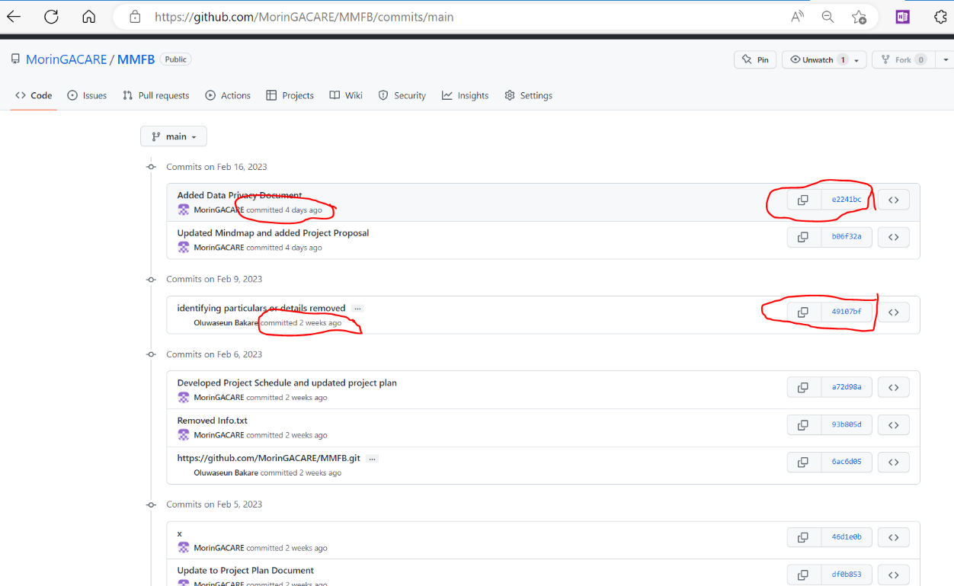

Figure 2: GitHub Version Control

1. By clicking on the commit (top right on the site), one can see the versions of the documents as they were ‘pushed’ top the GitHub.

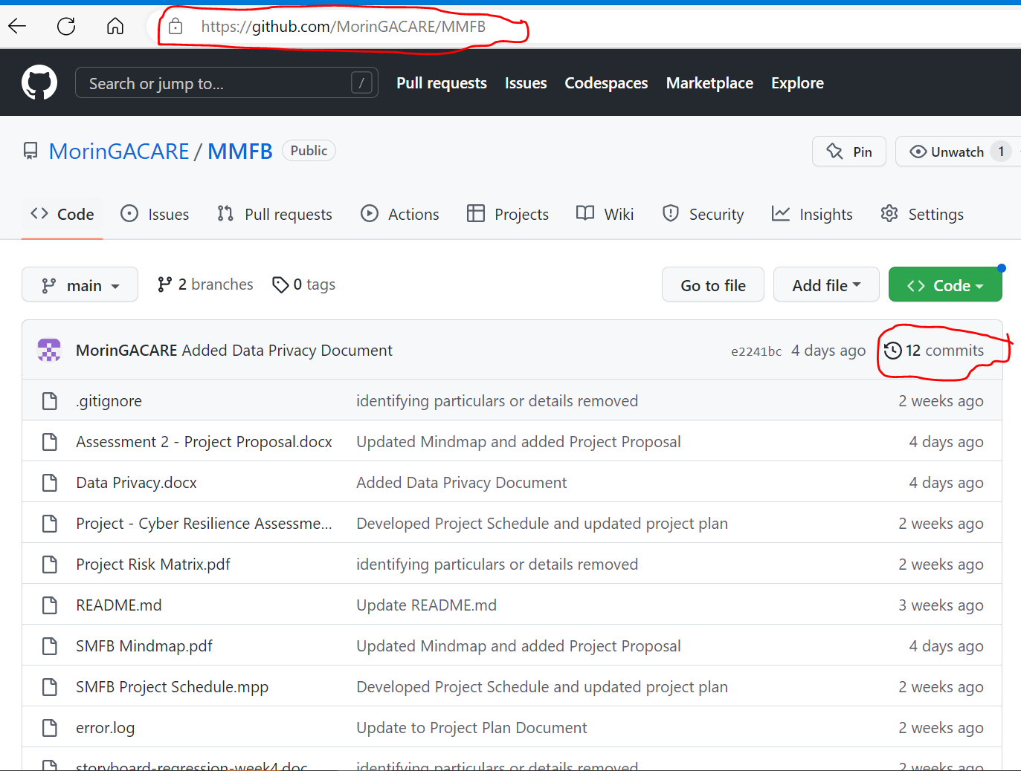

Figure 1: GitHub Repository